**Courtney-IBM Watson Big Data Project **

Goal:

1. Create a description of the individual described based upon the job description text for Job #302023856 University of Southern California Los Angeles, CA for Senior Data Scientist
2. Derive a Needs and Values Emotional Attribute profile description of that virtual person described by the job description/qualifications text to aid in developing meaningful interview questions

**Methods**: IBM Developer Watson Concept Analysis and Personality Insights

This project programs a request to the Watson supercomputer to create the virtual person described in a job description. When developing a job description HR attempts to envision the perfect person for the job and the qualifications that would be needed for the job. I wanted to ask….what does that vision really look and function like if all those listed qualities were actually embodied in one person exactly as written in the job description.

**Insights generated**: The results and insights were surprising and very interesting. Elucidating sectors of the Big 5 that should be considered/assessed during interviews that can be problematic traits (if present) on the job working with a team. **The insights can also be used to re-craft a job description if the current description inadvertently skews for unexpected traits.

**Output developed**: IBM’s Watson took the raw text data unchanged from the job description/qualifications as input and generated an incredibly detailed virtual person from the requested qualities in the job description.

**Challenges encountered**: The learning curve working with Watson and the developer tools to gain the insight I wanted to analyze. Not just text matching but using Watson to determine the concepts behind the input.

**Results**



USC Senior Data Analyst Virtual Candidate Description

USC senior data analyst candidate description's Personality *

Your proposed candidate is shrewd, skeptical and restrained.

They are empathetic: feel what others feel and are compassionate towards them. They are imaginative: and have a wild imagination. And they are philosophical: open to and intrigued by new ideas and love to explore them.

More than most people, their choices are driven by a desire for prestige.

They are relatively unconcerned with tradition: they care more about making their own path than following what others have done. They consider achieving success to guide a large part of what they do: they seek out opportunities to improve themselves and demonstrate that they are a capable person.

*\*Compared to most people who participated in IBM’s surveys.*

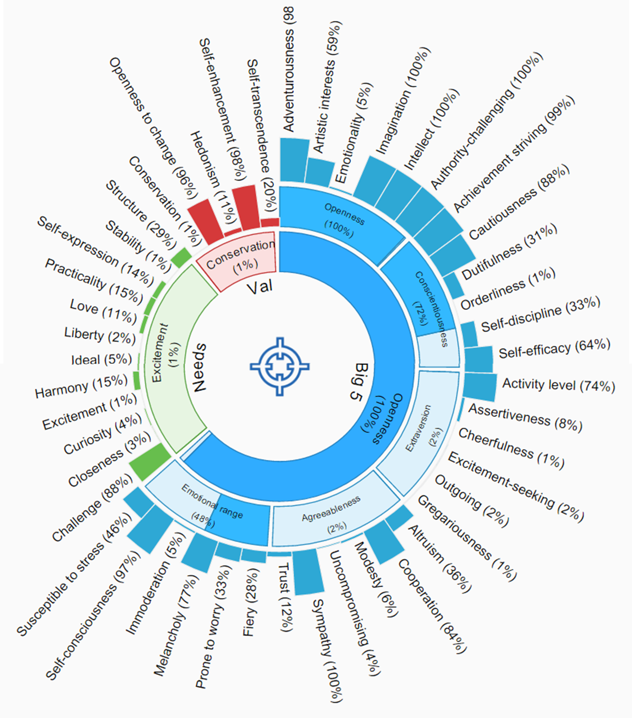

**Results: Big 5, Needs and Values attributes**

Big 5 Openness(100%)Openness(100%)Adventurousness (98%)Artistic interests (59%)Emotionality (5%)Imagination (100%)Intellect (100%)Authority-challenging (100%)Conscientiousness(72%)Achievement striving (99%)Cautiousness (88%)Dutifulness (31%)Orderliness (1%)Self-discipline (33%)Self-efficacy (64%)Extraversion(2%)Activity level (74%)Assertiveness (8%)Cheerfulness (1%)Excitement-seeking (2%)Outgoing (2%)Gregariousness (1%)Agreeableness(2%)Altruism (36%)Cooperation (84%)Modesty (6%)Uncompromising (4%)Sympathy (100%)Trust (12%)Emotional range(48%)Fiery (28%)Prone to worry (33%)Melancholy (77%)Immoderation (5%)Self-consciousness (97%)Susceptible to stress (46%)Needs Excitement(1%)Challenge (88%)Closeness (3%)Curiosity (4%)Excitement (1%)Harmony (15%)Ideal (5%)Liberty (2%)Love (11%)Practicality (15%)Self-expression (14%)Stability (1%)Structure (29%)Values Conservation(1%)Conservation (1%)Openness to change (96%)Hedonism (11%)Self-enhancement (98%)Self-transcendence (20%)

**Text data used for the analysis as primary input:**

Data input taken directly from Job #302023856 University of Southern California Los Angeles, CA Job description for Sr. Data Analyst <http://www.beyond.com/jobs/search?id=302023856&aff=39D7A8D9-A438-4E09-972C-EA4AA99FA062&reg=3>

**Input:**

Coordinating Analytics Projects: coordinate projects that focus on understanding how data is created and used to inform decision making; and working collaboratively with programmers to develop analytical tools. Data Management and Analysis: implement data models to find the best ways to turn data into insight. We are looking for people who can maintain a high degree of rigor and hyper attention to detail but who also experiment in their approach and methodology. Uncovering and Articulating Insights: integrate, manipulate and analyze complex data from multiple sources using a variety of tools and techniques to develop insights; and make these easy to understand by creating captivating visuals that help the institute drive the translation of analytics insights into actionable business recommendations for strategic decision making.

Key qualifications

◦Ability to work flexibly and efficiently: projects vary in length and are very fast-paced, must be comfortable adapting approach to fit the project’s needs and constraints; must exercise a balance between design/inspiration and academic research rigor in order to move quickly from planning, to conducting analysis, to synthesizing insights, to recommending directions and opportunities

◦Complete command of Excel (an Excel skills assessment will be provided at time of interview)

◦Strong analytical and strategic thinking skills

◦Ability to construct stories from data and make actionable recommendations based on discovered insights

◦Articulate, excellent writer, good speaker and better listener

◦Comfortable with ambiguity, able to multitask and prioritize competing responsibilities

60% Data Analysis and Visualization

◦Coordinates integration of multiple, disparate data sets, reviews data for anomalies, investigates to identify cause, corrects data inaccuracies and inconsistencies, and determines the best approach for analysis

◦Data analysis from multiple sources and assists in interpretation of results using a variety of techniques to uncover insights

◦Provides recommendations and conclusions gained from analyzing data

◦Determines appropriate format for data and results presentation

◦Produces visuals (infographics, graphs, tables, charts, etc.) that make complex data easy to understand

◦Coordinates ongoing production of reports that effectively present and summarize data (e.g., service and resource dashboards) to review by leadership

30% Analytics Project Coordination

◦Gathers data and information from key stakeholders to inform the development of projects

◦Performs assigned data collection and analysis, facilitates resolution of issues with guidance from the Sr. Data Manager, and reports status on project plans and progress at regular intervals to leadership

◦Tracks the changes that occur to the project and associated documentation

Working with developers:

◦Participates in the definition and planning of database applications and functionality

◦Refines systems and applications that use the databases. Anticipates and accommodates future technical and programmatic needs.

◦Defines logical attributes and inter-relationships and designs data structures to accommodate database production, storage, maintenance and accessibility.

10% Other responsibilities as assigned